Ultimate-Apache-Camel-for-Enterprise-AI-Integrations

Prerequisites:
1. Run run-00-infrastructure.bat to have Docker services started.
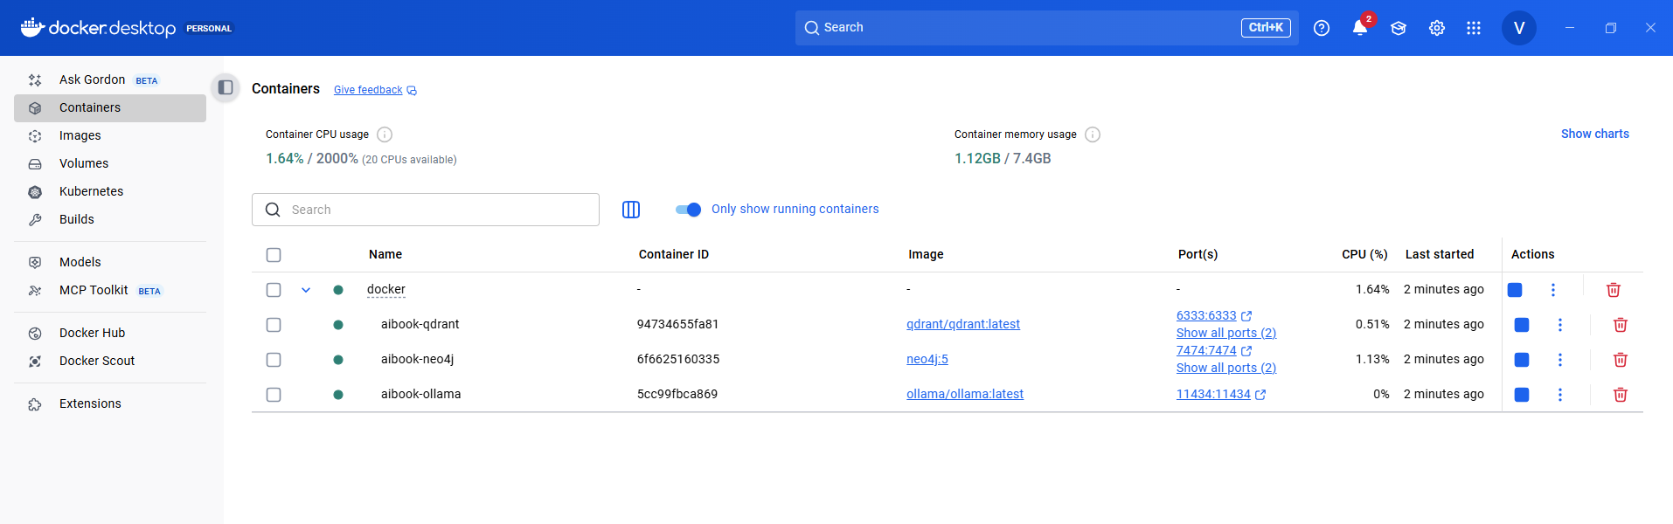
2. Run kill-app.bat to kill any processes running on port 8080.
3. Make sure:
- Qdrant healthy -- http://localhost:6333/dashboard#/collections 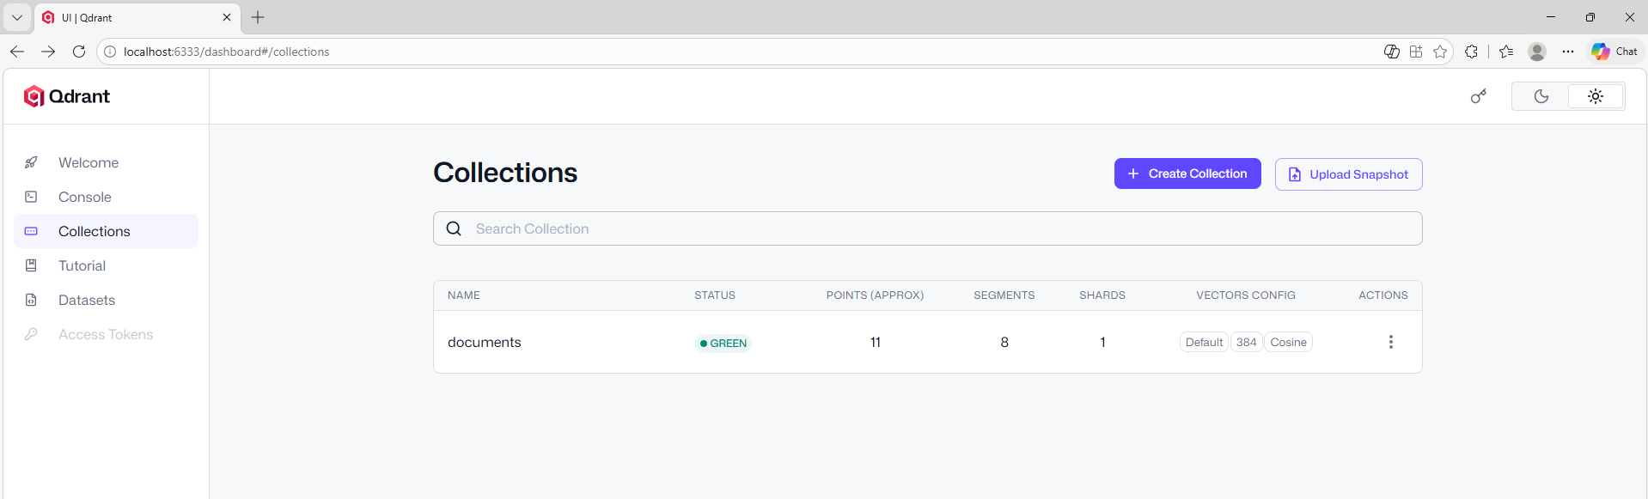
- Neo4j healthy -- http://localhost:7474/browser/
  - Username - neo4j
  - Password - password
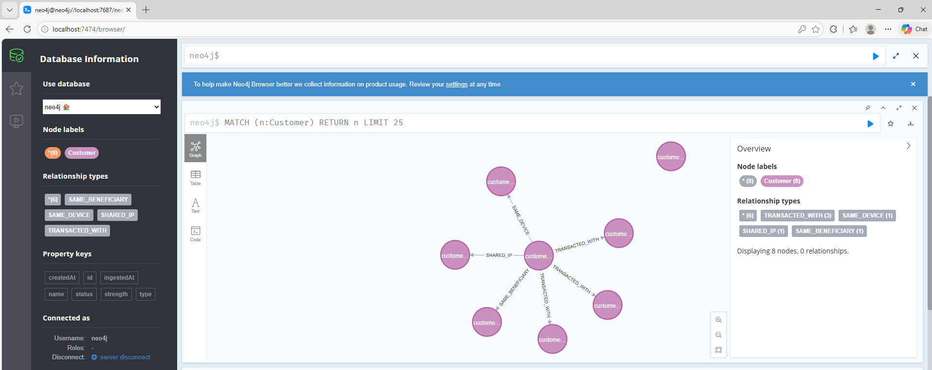
- Ollama healthy -- http://localhost:11434/api/tags
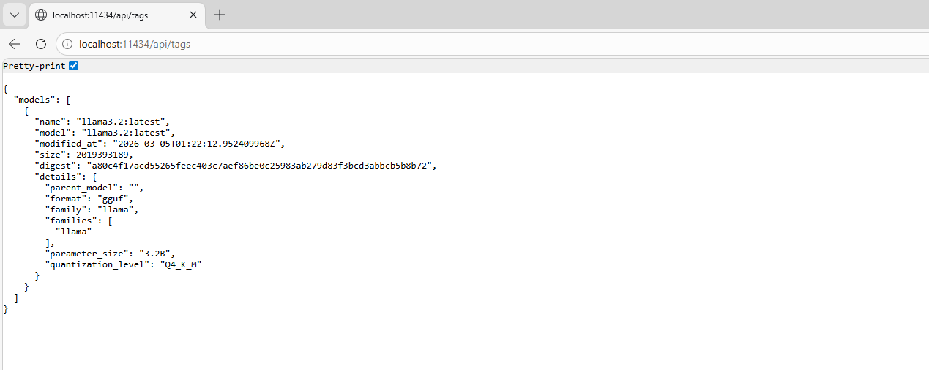
3. Run run-complete-demo-fixed.bat
- Spring Boot - http://localhost:8080/actuator/health
Console Logs during 5 Pipeline executions:
Output Directories & Logs:
